**DUYTAN UNIVERSITY**

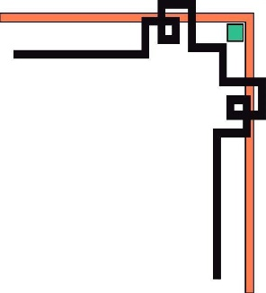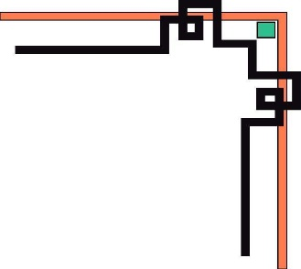

**INTERNATIONAL SCHOOL**

**--------------🙖🙐✰🙖🙐-------------**



**CMU-SE 100**

**INTRODUCTION TO SOFTWARE ENGINEERING**

**SYNTHESIS REPORT GROUP PROJECT**



**Mentor: Msc. Huy Nguyen Dang Quang**

***Team Member*:**

**Vinh, Nguyen Quoc**

**Vu, Nguyen Van**

**Vu, Tran Duy Thanh**

**Huy, Ho Xuan**

**Nhat, Tran Minh**

**Group Project - Mentor:**

Name Signature Date : Dec 25, 2023

Da nang, 12/2023

**PROJECT INFORMATION**

|  |  |
| --- | --- |
| **Project Acronym** | CMU.PRJ |
| **Project Title** | SYNTHESIS REPORT GROUP PROJECT | | | |
| **Start Date** | 02/12/2023 | **End Date** | 25/12/2023 | |
| **Lead Institution** | International School, Duy Tan University | | | |
| **Team Member** | **Name** | **Email** | | **Phone** |
| **1** | NGUYEN QUOC VINH | nguyenquocvinh.bocking@gmail.com | | +84888695679 |
| **2** | NGUYEN VAN VU | nguyenvanvu12012005@gmail.com | | +84905783026 |
| **3** | TRAN DUY THANH VU | tranduythanhvu@gmail.com | | +84342391361 |
| **4** | HO XUAN HUY | hoxuanhuyhitclub@gmail.com | | +84773536100 |
| **5** | TRAN MINH NHAT | tranminhnhatboxing@gmail.com | | +84324728933 |

**DOCUMENT NAME**

|  |  |  |  |
| --- | --- | --- | --- |
| **Document Title** | **Synthesis Report Group Project Document** | | |
| **Reporting Period** | 25 – Dec – 2023 | | |
| **Author(s)** | NGUYEN QUOC VINH | | |
| **Role** | Leader | | |
| **Date** | 25-Dec-2023 | **Filename** | CMU.PRJ.Team_5.Zip |

**SIGNATURE**

***Document Approvals:*** *The following signatures are required for approval of this document.*

|  |  |  |  |
| --- | --- | --- | --- |
| **Mentor** | Huy, Nguyen Dang Quang | **Signature:** |  |
| **Date:** |  |
| **Team Lead** | Vinh, Nguyen Quoc | **Signature:** | VinKay |
| **Date:** | 25,Dec, 2023 |
| **Team member(s)** | Vu, Nguyen Van | **Signature:** | Vu |
| **Date:** | 25,Dec, 2023 |
| Vu, Tran Duy Thanh | **Signature:** | Vu |
| **Date:** | 25,Dec, 2023 |
| Huy, Ho Xuan | **Signature:** | Huy |
| **Date:** | 25,Dec, 2023 |
| Nhat, Tran Minh | **Signature:** | Nhat |
| **Date:** | 25,Dec, 2023 |
|  | **Signature:** |  |
| **Date:** |  |

**REVISION HISTORY**

|  |  |  |
| --- | --- | --- |
| **Version** | **Date** | **Description** |
| **1.0** | 02/12/2023 | **The Marina Restaurant Group Project aimed to analyze and evaluate various aspects of Marina Restaurant, including its operations, customer service, and overall performance. This synthesis report provides an overview of the findings and recommendations generated by the project team.** |

**TABLE OF CONTENTS**

**1. INTRODUCTION**

**MARINA SEAFOOD RESTAURANT** - Explore the Fresh Seafood Flavors

**Address**: 73 Nguyen Van Linh, Hai Chau Ward, Hai Chau District, Da Nang

**Phone Number**: 0123 789 456

**Business Field**: A restaurant specializing in delicious fresh seafood

*Welcome to* ***MARINA SEAFOOD RESTAURANT****, an excellent destination for seafood enthusiasts who love the taste of fresh and delicious seafood. Located at 73 Nguyen Van Linh, we take pride in being the perfect place for you to discover unique flavors and the freshest ingredients from the sea.*

*At* ***MARINA SEAFOOD RESTAURANT****, we always prioritize freshness and quality. Our menu is diverse with unique seafood dishes, ranging from fresh seafood, steamed dishes, stir-fried dishes, sushi, sashimi, and many other seafood specialties. Our talented kitchen team is always ready to create stylish and enticing seafood feasts.*

***MARINA SEAFOOD RESTAURANT*** *is not only a place to enjoy great food but also a luxurious and comfortable environment. With modern decor and a space filled with natural light, we provide an ideal setting for you to relax and enjoy culinary delights with family and friends, or to host special events such as weddings, group meetings, or anniversary parties.*

*Come and experience the unique flavors of fresh seafood at* ***MARINA SEAFOOD RESTAURANT****. We are committed to offering you a dining experience like no other place. Feel free to contact us at the phone number* ***0888 6956 79*** *to make a reservation or to learn more about our menu and services.*

*Let* ***MARINA SEAFOOD RESTAURANT*** *be the ideal destination for all seafood lovers and those seeking a high-class culinary experience. We look forward to serving you!*

**2. DESCRIBE BUSINESS PROCESSES OF RESTAURANT**

*The activities of* ***MARINA SEAFOOD RESTAURANT****, focusing on delicious fresh seafood, include several key operational processes to ensure that the restaurant operates efficiently and provides an excellent culinary experience for customers.*

**1. Selecting and Procuring Ingredients:*****MARINA SEAFOOD RESTAURANT*** *must regularly choose and purchase various types of fresh seafood and seafood ingredients from reliable suppliers.*

**2. Preparation and Cooking:** *The chefs at* ***MARINA SEAFOOD RESTAURANT*** *must use food preparation techniques to ensure the flavors and freshness of the dishes are preserved. This includes cooking seafood, making sushi, sashimi, and various other seafood dishes.*

**3. Menu Management: *MARINA SEAFOOD RESTAURANT*** *must maintain a diverse and appealing menu for customers. Menu management involves designing and updating the menu, managing prices, and selecting exceptional dishes.*

**4. Service and Guest Interaction***: The staff provides a memorable customer experience by welcoming guests, assisting in menu selection, taking orders, and ensuring that food and beverages are delivered accurately to the customer's table.*

**5. Human Resources Management:** *This includes recruiting, training, and managing staff within the restaurant, including chefs, servers, and other employees. Ensuring that staff understand and perform their duties professionally is essential.*

**6. Financial Management:** *Ensuring that the restaurant's finances are carefully managed, including expense management, budgeting, and supplier payments.*

**7. Advertising and Marketing: *MARINA SEAFOOD RESTAURANT*** *needs advertising and marketing campaigns to attract new customers and maintain relationships with existing customers through social media, online advertising, and special events.*

**8. Quality Control and Food Safety:** *Ensuring that food is stored, prepared, and served safely to customers. Regular quality checks of food items are conducted to ensure the highest quality.*

**9. Risk Management and Compliance:** *Ensuring that the restaurant complies with all legal regulations related to food safety, sanitation, and other business regulations.*

**10. Special Events Management*:*** *If* ***MARINA SEAFOOD RESTAURANT*** *hosts special events such as weddings, anniversary parties, or other special occasions, there should be specific processes in place to manage and execute these unique requirements.*

*These processes must work together to create an excellent and successful culinary experience for* ***MARINA SEAFOOD RESTAURANT*** *and our customers.*

**3. LIST OF PARTICIPANTS TO REQUIREMENTS GATHERING**

**1. Customers:** *These are the individuals who use the services of* ***MARINA SEAFOOD RESTAURANT*** *Collecting feedback from customers regarding the menu, service quality, and event organization experience can help improve the service.*

**2. Staff:** *Employees in the restaurant, including chefs, servers, managers, and other staff, can provide information about internal processes and other issues related to daily operations.*

**3. Chefs and Head Chef:** *Chefs are the individuals responsible for food preparation. They can provide information on how to prepare dishes and ingredient requirements.*

**4. Management and Owner:** *Restaurant managers and owners have the authority to make decisions regarding management and development. They can provide information about business strategies and goals.*

**5. Food Suppliers:** *Food suppliers are the primary source of ingredients for the restaurant. Gathering information from them about the freshness and quality of products can be important.*

**6. Special Guests:** *If* ***MARINA SEAFOOD RESTAURANT*** *hosts special events such as weddings or anniversary parties, collecting requirements from these special guests is important to ensure their satisfaction.*

**7. Culinary Experts:** *Consulting culinary experts can provide professional opinions on the menu and ways to enhance the culinary experience.*

**8. Regulatory Agencies and Regulations:** *Government agencies or regulations may impose requirements related to food safety, sanitation, and business regulations. Gathering information on regulatory compliance is important.*

**9. Social Media Customers:** *Monitoring feedback and reviews from customers on social media platforms can help understand their perception of* ***MARINA SEAFOOD RESTAURANT****.*

**10. Competitors:** *Researching the operations and menus of competing restaurants can provide information about trends and opportunities for improvement.*

*This helps improve the operations and services of* ***MARINA SEAFOOD RESTAURANT***

**4. THE TECHNICALS USING TO REQUIREMENTS GATHERING**

**1. Direct Customer Interviews:**

*●* **Purpose***: Conducting direct customer interviews allows you to create a direct channel of conversation to understand their needs and opinions. This helps establish a personalized connection and build a relationship with customers.*

*●* **How to Conduct:** *Organize meetings or individual interviews with customers to inquire about their experiences, menu preferences, feedback on services, and areas they would like to improve.*

**2. Online Surveys:**

**● Purpose:** *Online surveys are an effective way to gather feedback from multiple customers simultaneously. It can be easily shared through email or on the restaurant's website.*

*●* **How to Conduct:** *Create an online survey with questions related to the menu, service quality, and areas for improvement. Then, share the link with customers for them to provide input.*

**3. Direct Observation:**

*●* **Purpose:***Directly observing staff and customers in the restaurant helps you understand the operational processes and identify potential issues or improvement opportunities.*

*●* **How to Conduct:** *Monitor activities in the restaurant, paying attention to how staff interacts with customers, menu management, and food service.*

**4. Website with Feedback Feature:**

*●* **Purpose:** *Creating a restaurant website with a feedback feature allows customers to easily share their opinions and reviews. This can help you continuously collect feedback from the online community.*

*●* **How to Implement:** *Create a website for the restaurant with a "Contact" or "Submit Feedback" section that allows customers to enter their information and opinions.*

**5. Direct Exchange Based on Models:**

*●* **Purpose:** *Using models or simulations to facilitate direct exchanges on how the restaurant operates and can be improved.*

*●* **How to Implement:** *Create a model or simulation of the restaurant, then organize discussions or direct exchanges with team members or employees to identify specific improvements.*

These techniques can be combined or used independently to gather requirements and opinions from customers and staff. Combining multiple methods helps ensure you have a comprehensive understanding of how **MARINA SEAFOOD RESTAURANT** operates and how to enhance the customer experience.

**5. ASSIGNMENT TEAM MEMBER TO REQUIREMENTS GATHERING**

**Project:** Restaurant " ***MARINA SEAFOOD*** "

| **Role** | **Member** | **Mission** |
| --- | --- | --- |
| **Leader** | **NGUYEN QUOC VINH** | - Manage the entire requirements gathering process.  - Divide and assign specific tasks to each team member.  - Identify and ensure the progress of the requirements gathering process. |
| **Business Analyst** | **NGUYEN VAN VU** | - Contact the restaurant owner to understand the business requirements and core functionalities of the restaurant.  - Conduct interviews with the owner and restaurant managers to gather information about the current operational processes.  - Create a list of key functional requirements. |
| **UX/UI Designer** | **TRAN DUY THANH VU** | - Gather information about the current user interface (if any) and learn about design requirements from stakeholders and management.  - Propose user interface and user experience (UI/UX) requirements. |
| **Quality Assurance Analyst** | **HO XUAN HUY** | - Identify testing requirements and propose test cases based on information about functional and non-functional requirements.  - Gather information about quality and performance standards required. |
| **Security Expert** | **TRAN MINH NHAT** | - Identify the necessary security requirements for the project and research security requirements from the stakeholders.  - Propose security measures to ensure the safety of data and systems. |

**6. INTRODUCTION PROJECT**

**6.1. Project Objectives**

• Develop a mobile application and website for **MARINA SEAFOOD RESTAURANT** to provide online ordering services and enhance the customer experience.

• Increase sales and competitiveness of **MARINA SEAFOOD RESTAURANT** in the food market.

**6.2. Project Scope**

• Develop a mobile application for both Android and iOS platforms.

• Build a website for online ordering and provide information about the menu, prices, location, and news of **MARINA SEAFOOD RESTAURANT**

• Integrate online payment for orders.

• Develop an order management system and a restaurant management system to manage data and restaurant operations.

• Ensure the security and privacy of customer information.

**6.3. Estimated Value**

• Increase sales for **MARINA SEAFOOD RESTAURANT** by providing convenient online ordering services for customers.

• Enhance customer experience through a user-friendly and convenient user interface.

• Create a professional mobile application and website to promote the brand and make a positive impression on customers.

**6.4. Project group**

• Mobile application development team.

• User interface design team.

• Quality assurance and testing team.

• Security and information security team.

• Project management and coordination team.

**6.5. Project Management Principles:**

• The project will adhere to the Agile methodology to ensure flexibility in the development process and rapid response to changing requirements.

• The project will comply with security and privacy standards throughout the development and operation of the application.**6.6. Estimated Start And Closing Date:** March 1, 2023

**Expected Closing Date:** June 30, 2023

**6.7. Project Budget:** 500,000 USD

**6.8. Approving Authority:** Executive Director of **MARINA SEAFOOD RESTAURANT**

- **Project Contact:** NGUYEN QUOC VINH (nguyenquocvinh.bocking@gmail.com) *Contact information of the person responsible for the project*

- **Project Achievements:**

• Completed user interface (UI/UX) design.

• Developed mobile applications for Android and iOS.

• Built an online ordering website.

• Integrated online payment functionality.

• Developed an order management system.

• Developed a restaurant management system.

• Ensured data security and information privacy.

• Conducted application testing and quality assurance.

• Deployed and operated the application.

• Provided guidance and training.

**6.9 Identify the Functional Requirement & Non-Functional Requirement**

## **a)** **High level Functional Requirement (FR)**

| **No.** | **Functional Requirement** | **Description** | **Priority** | **Status** |
| --- | --- | --- | --- | --- |
| FR.1 | Online Ordering | Allow customers to place orders online by selecting items from the menu and adding them to the cart. | High | Completed |
| FR.2 | View Menu | Display a list of menus with information about dishes, prices, and illustrated images. | Medium | In Progress |
| FR.3 | Online Payment | Provide a secure and convenient online payment feature for orders. | High | Testing |
| FR.4 | Order Management | Implement an order management system that enables restaurant staff to view and process customer orders. | High | In Progress |
| FR.5 | Restaurant Information Management | Allow administrators to update restaurant information, including menu items, prices, and location. | Medium | Testing |
| FR.6 | Security and Privacy | Ensure data privacy and security for customer personal information and order management data. | High | Completed |

**b) List of Non-Functional Requirement**

| **No.** | **Non-Functional Requirement** | **Description** | **Priority** | **Status** |
| --- | --- | --- | --- | --- |
| MC.1 | Performance | Ensure the application runs smoothly and quickly on various mobile devices and web browsers. | High | In Testing |
| MC.2 | Security | Protect customer's personal data and order management information from unauthorized access. | High | Completed |
| MC.3 | Privacy | Ensure the privacy of customer's personal information and comply with privacy regulations. | High | In Development |
| MC.4 | Browser Compatibility | Ensure that the website works well on popular web browsers (Chrome, Firefox, Safari, Edge). | Medium | Testing |
| MC.5 | Mobile Compatibility | Ensure the mobile app works well on various mobile devices and operating systems (iOS, Android). | Medium | Testing |
| MC.6 | Page Load Performance | Ensure fast page loading times for both the website and mobile app to improve user experience. | High | In Development |
| MC.7 | Accessibility (508 Compliance) | Ensure accessibility for people with disabilities and comply with web accessibility standards (508 compliance). | Medium | Completed |

**7. THE USER REQUIREMENT ANALYSIS**

**7.1 Business Function Diagram**

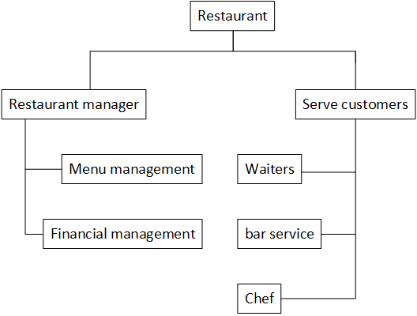

**7.2 Context Model**

**a) Context Model**

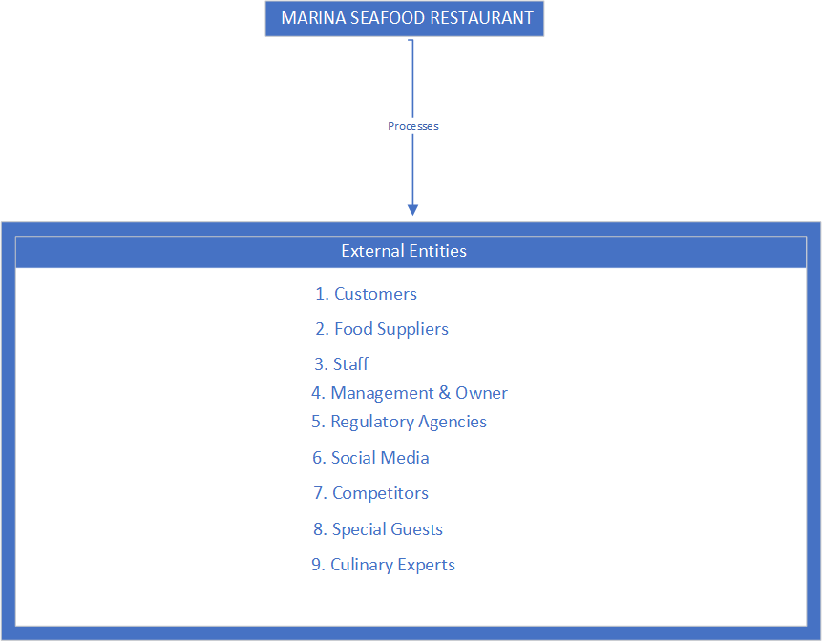

**b) System Context Description**

**7.3 List of Actor**

|  |  |
| --- | --- |
| **Actor** | **Description** |
| **Customers** | Primary restaurant patrons who visit to dine and enjoy seafood |
| **Food Suppliers** | Entities providing fresh seafood and ingredients to the restaurant |
| **Staff** | Restaurant employees, including chefs, servers, managers, and more |
| **Management & Owner** | Restaurant employees, including chefs, servers, managers, and more |
| **Regulatory Agencies** | Individuals responsible for managing and owning the restaurant, making strategic decisions. |
| **Regulatory Agencies** | Government authorities enforcing food safety, sanitation, and business regulations. |
| **Social Media Users** | Customers engaging on social media platforms, leaving reviews, feedback and sharing experiences. |
| **Competitors** | Other restaurants or businesses in the same industry, impacting MARINA SEAFOOD RESTAURANT's strategies and competitiveness. |
| **Special Guests** | Individuals or groups hosting special events at the restaurant, such as weddings or parties. |
| **Culinary Experts** | Professionals or consultants with culinary expertise providing insights on the menu and food preparation |

**7.4. List of Use Cases**

|  |  |  |
| --- | --- | --- |
| Use case ID | Use case name | Functional Req. |
| *UC.01* | *Place an Order* | *FR1.1* |
| *UC.02* | *Edit Place Information* | *FR1.2* |
| *UC.03* | *Login* | *FR1.3* |
| *UC.04* | *View Menu* | *FR1.4* |
| *UC.05* | *Process Payment* | *FR1.5* |
| *UC.06* | *Prepare Food* | *FR1.6* |
| *UC.07* | *Serve Food* | *FR1.7* |
| *UC.08* | *Manage Reservations* | *FR1.8* |
| *UC.09* | *Manage Inventory* | *FR1.9* |
| *UC.10* | *Train Staff* | *FR1.10* |
| *UC.11* | *Advertise Specials* | *FR1.11* |
| *UC.12* | *Handle Customer Feedback* | *FR1.12* |
| *UC.13* | *Maintain Cleanliness* | *FR1.13* |
| *UC.14* | *Manage Finances* | *FR1.14* |
| *UC.15* | *Perform Health and Safety Inspections* | *FR1.15* |
| *UC.16* | *Market the Restaurant* | *FR1.16* |
| *UC.17* | *Online Ordering* | *FR1.17* |
| *UC.18* | *Delivery Service* | *FR1.18* |
| *UC.19* | *Loyalty Program* | *FR1.19* |
| *UC.20* | *Schedule Staff* | *FR1.20* |
| *UC.21* | *Manage Employee Records* | *FR1.21* |
| *UC.22* | *Vendor Management* | *FR1.22* |
| *UC.23* | *Waste Management* | *FR1.23* |

**8. PROJECT PLAN**

|  |  |  |  |  |  |
| --- | --- | --- | --- | --- | --- |
| **No.** | **Task Name** | **Duration (Days)** | **Start** | **Finish** | **Assign to** |
| **1** | **Initial** | **17 day** | **02/12/2023** | **25/12/2023** | **Vinh,** **Van** **Vu,Vu,Huy,Nhat** |
| 1.1 | Project Kick-off Meeting | 2 day | 02/12/2023 | 03/12/2023 | Van Vu |
| 1.2 | Discuss about project ideal | 2 day | 03/12/2023 | 04/12/2023 | Nhat |
| 1.3 | Create Proposal Document | 2 day | 04/12/2023 | 05/12/2023 | Huy |
| 1.4 | Start project | 9 day | 05/12/2023 | 15/12/2023 | **Vinh**, Van Vu, Thanh Vu,Huy,Nhat |
| 1.5 | Web design | 2 day | 15/12/2023 | 17/12/2023 | Nguyen Quoc Vinh, Thanh Vu |
| 1.6 | Create websites | 4 day | 17/12/2023 | 20/12/2023 | Nguyen Quoc Vinh |
| 1.7 | Fix bug | 2 day | 20/12/2023 | 21/12/2023 | **Vinh**, Van Vu, Thanh Vu |
| 1.8 | Complete | 1 day | 21/12/2023 | 21/12/2023 | Nguyen Quoc Vinh |

**9.** **TECHNICAL CONSTRAINTS**

### **9.1 Technical to develop:**

* ***Languages****: Python, Nodejs, React Native, Reactjs*
* ***Server:*** *Socket.io*

### **9.2 Environment:**

* ***Web browsers****: Google Chrome, Molliza Firefox, Apple Safari, Cốc Cốc, Microsoft Edge.*
* ***Environment:*** *Microsoft windows, Mac Os, Android, iOS,..*

### **9.3 Another:**

* ***Management tool****: Trello, Slack*
* ***Design tool****: Figma*
* ***Manage Source code tool****: Git,Github*
* ***Test tool*** *: Katalon Studio*

**10. ANALYSIS & MODELING REQUIREMENT**

**10.1. Use Case Diagram**

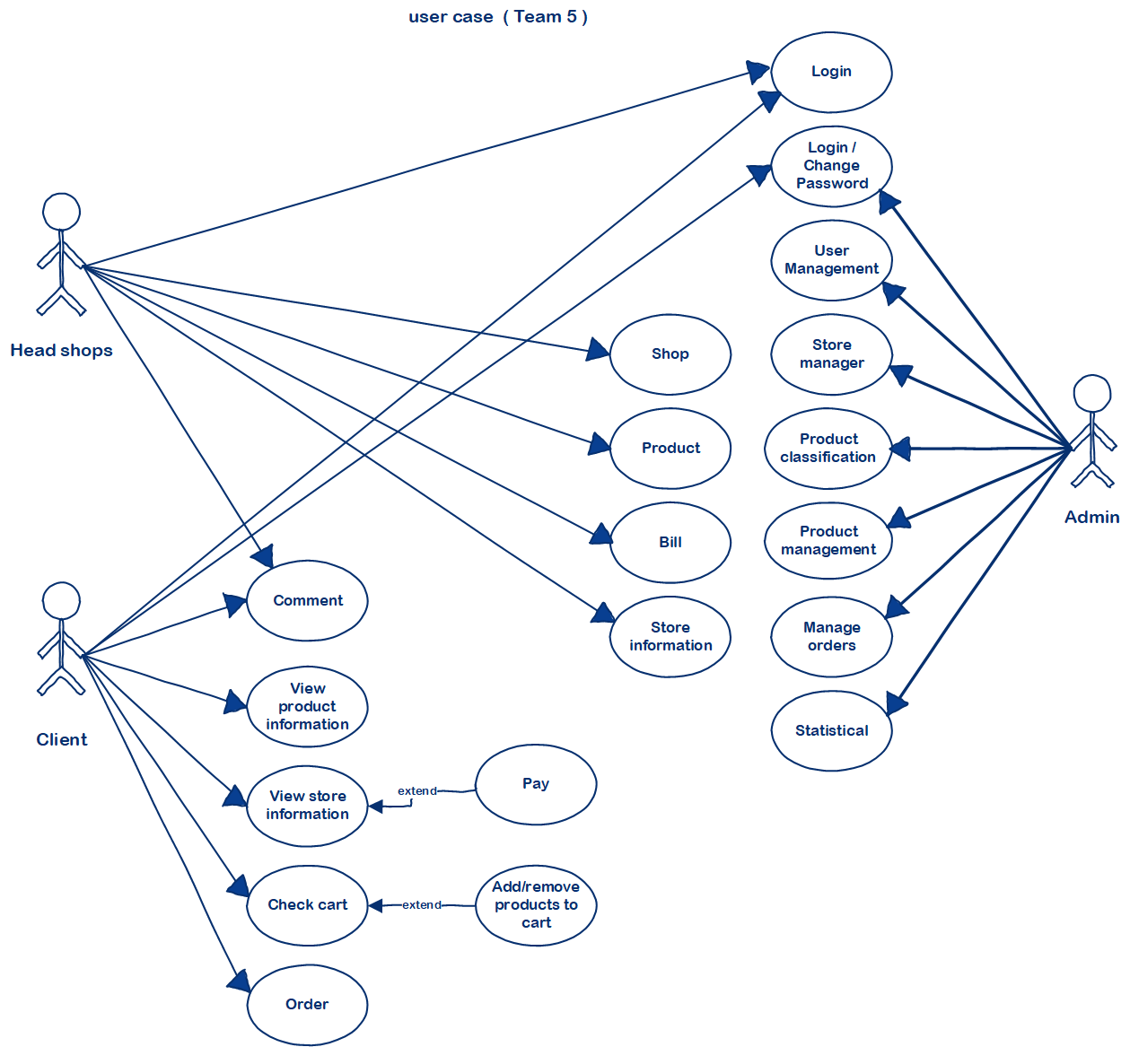

## **10.2.** **List of Business Rule**

|  |  |  |
| --- | --- | --- |
| Code | Business rules | Use case |
| *BR1* | *Rank of a user will be se based on the user’s*  *contribution point (CP)* | *UC.02* |
| *BR2* | *Contribution Point (CP) is calculated as follow:*  *‐ Starter point for every user is 10 points*  *‐ Create a place: + 20 point*  *‐ Your place gets deleted: ‐ 25 point* | *UC.02* |
| *BR3* | *For user has more than 1000 point (senior user):*  *‐ Can edit a place directly*  *‐ Can upload place’s image directly*  *‐ Can approve suggested edit*  *‐ Can approve suggested images*  *‐ Set a revision as current* | *UC. 02* |
| *BR4* | *For user has less than 1000 point (junior user):*  *‐ a revision of a place created by these users*  *need approvals from senior users or admins to be*  *displayed* | *UC.02* |

**10.3. Activity Diagram**

**a) The steps performed of function abc….**

|  |  |  |
| --- | --- | --- |
| **Number** | **Item** | **Subsection** |
| **1** | **HOME** |  |
| **2** | **OUR STORY** |  |
| **3** | **OUR SERVICE** | **Cafe & Lounge** |
| **Seafood Restaurant** |
| **Corporate Event** |
| **Private Event** |
| **4** | **OUR MENU** |  |
| **5** | **PROMOTION** |  |
| **6** | **CAREER** |  |
| **7** | **BOOK A TABLE** |  |
| **8** | **CONTACT US** |  |

**b) Activity Diagram of function**

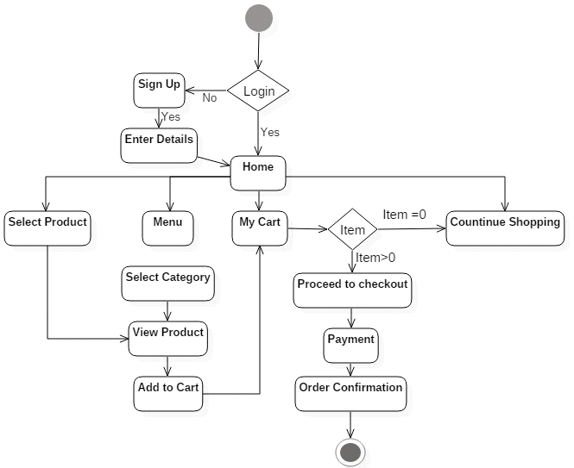

**11. INTERFACE DESIGN**

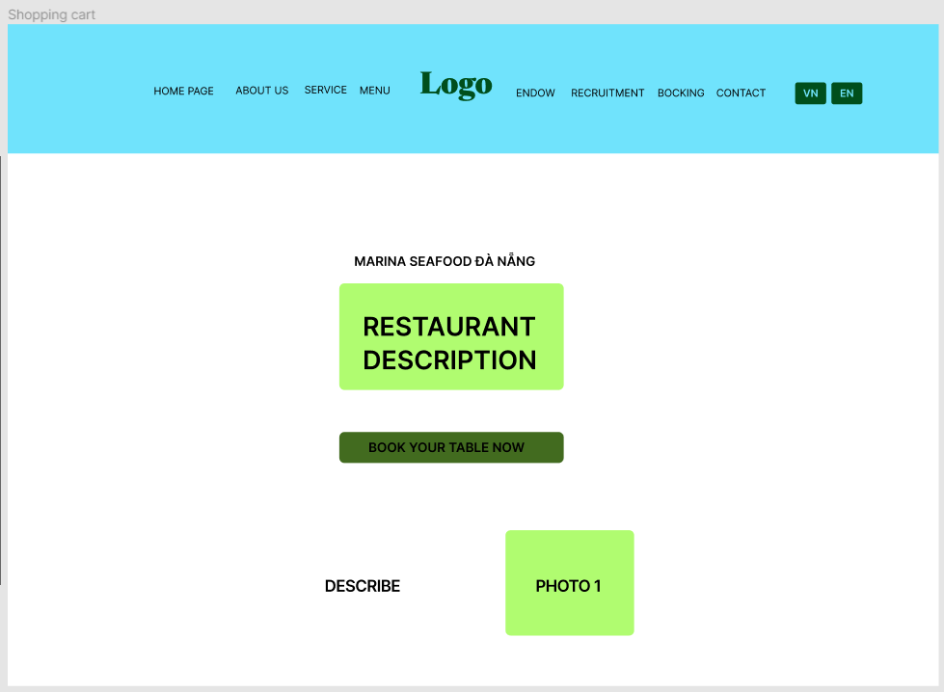

**11.1. Introduction tool design**

There are many tools like **Adobe XD, Sketch, Marvel, Balsamiq, Figma**... Personally, I use **Figma** for designing system applications. **Figma** is an online user interface design tool that allows for real-time collaboration, supports multi-platform design, and integrates with various plugins and applications, making design and prototyping easy and efficient.

**11.2 User Interface Design for ABC Function**

**Source *self-designed* :** <https://marinateam5.glitch.me/>

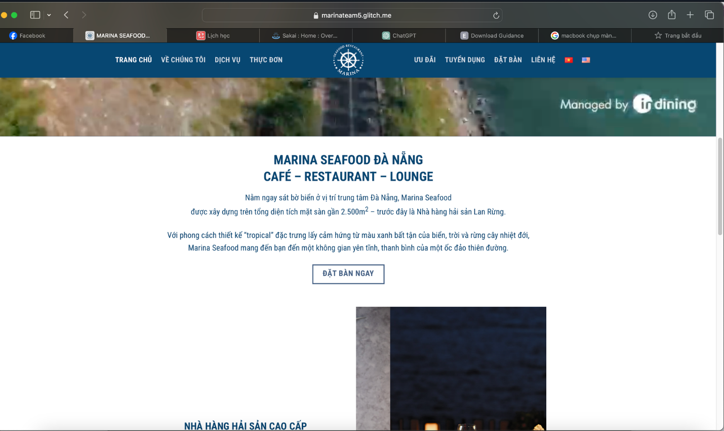**12. CONFIGURATION MANAGEMENT**

**a) Introduction the tool Source Code Management**

**GitHub** is a crucial tool for collaborative software development and source code management. It provides a powerful platform for tracking and managing changes in a project's source code, making it convenient for team collaboration and code review.

**b) Introduction Key Functional**

**Here are some key points about GitHub:**

**1. Repository (Repo):**

- **A repository** is where you store the entire source code of a project.

- **Each repository** has a unique URL, allowing others to access and work with your code.

**2. Basic GitHub Operations:**

- **Clone:** Copy a repository from GitHub to your local computer for work.

- **Commit**: Record changes in your source code along with a descriptive message.

- **Push**: Upload the committed changes to the GitHub repository.

- **Pull**: Download changes from the GitHub repository to your computer.

- **Branch**: Create separate working branches to develop features or fix issues without affecting the main branch (often named master/main).

- **Merge**: Combine branches after completing work.

**3. Collaboration and Version Management:**

- **GitHub** allows multiple people to work together on the same project.

- You can create pull requests to propose changes to the original project, which can be reviewed by others.

- **GitHub** offers powerful version control tools, enabling you to revert to previous versions or compare different versions.

**4. Community and Integration:**

- **GitHub** is also a large developer community. You can search, fork (copy and store others' projects), participate in open-source projects, and integrate with various development tools.

***GitHub plays a significant role in modern software development, fostering collaboration, code management, and code quality assurance.***

**c) The Screen Shot apply Source Code Management of team**

**Source:** https://github.com/vinkay215?tab=repositories

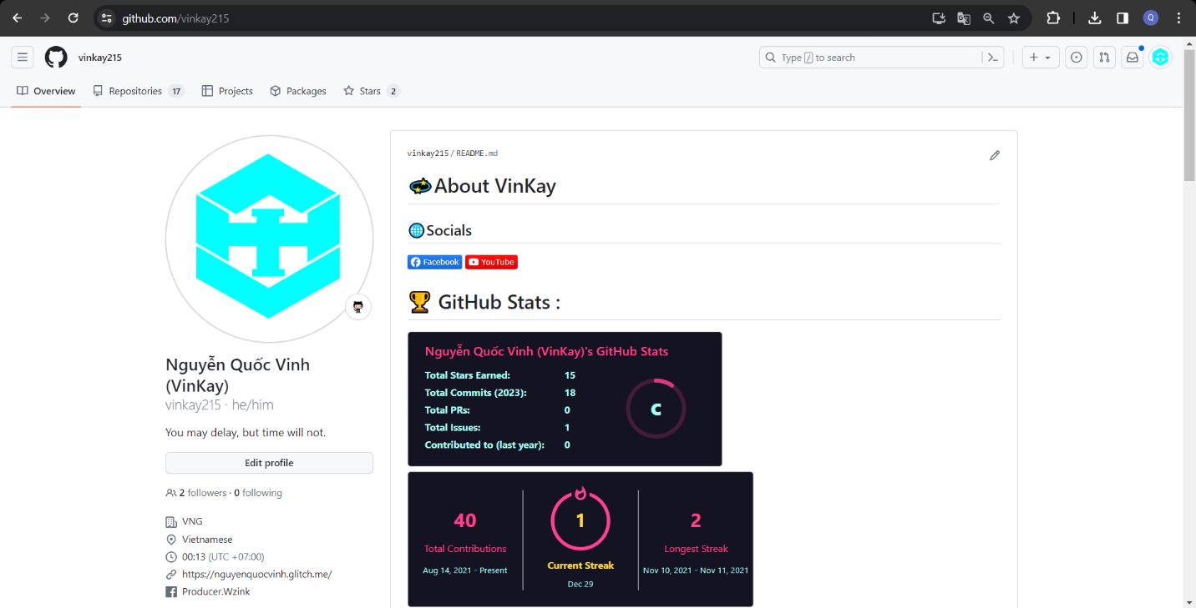

**13. TESTING**

**a) Introduction to method testing apply of this project**

**1. Functional Testing:**

- Functional testing involves checking whether the application performs the basic functions a restaurant needs, such as online ordering, menu management, payment, and order processing.

- Ensure these features work correctly and meet customer and business requirements.

**2. User Interface Testing:**

- User Interface Testing checks whether the application's interface is user-friendly and easy to use.

- Ensure that websites or mobile applications have the correct layout, colors, and interface elements as per the design.

**3. User Interaction Testing:**

- This testing examines how users interact with the application, including data entry, ordering, and payment.

- Ensure all features related to user interaction function accurately.

**4. Performance Testing:**

- Performance testing assesses the application's ability to operate smoothly and responsively under high load conditions.

- Ensure the application can handle multiple orders simultaneously without delay or crashing.

**5. Security Testing:**

- Security testing searches for security vulnerabilities in the application, such as SQL injection holes, Cross-Site Scripting (XSS), and other security issues.

- Ensure customer and business data are securely protected.

**6. Integration Testing:**

- Integration Testing checks the interaction between different parts of the system, including connections to payment systems, inventory management, and other external systems.

- Ensure all parts of the application work together cohesively.

**7. Non-functional Testing:**

- Non-functional testing examines aspects unrelated to the application's functionality, such as scalability, disaster recovery capability, and performance.

**8. System Testing:**

- System Testing tests the entire application system as a complete unit to ensure it functions correctly and meets overall requirements.

**9. Compatibility Testing:**

- Compatibility Testing checks the application on different web browsers and mobile devices to ensure it works correctly on all platforms.

**10. Load Testing:**

- Load Testing measures the application's ability to withstand high loads without performance issues.

**11. Backup and Recovery Testing:**

- This testing ensures the system can safely backup and recover data in the event of an incident.

**12. Usability Testing:**

- Usability Testing assesses the application's ease of use from the end-user's perspective.

**b) Test Cases**

***Look in the Project folder named test case***

**14. CONTRIBUTION**

*Team member contributed significantly to team's success (%)*

|  |  |  |  |  |
| --- | --- | --- | --- | --- |
| **No.** | **Participant** | **Role** | **Responsibilities** | **100 %** |
| **1** | **NGUYEN QUOC VINH** | **Leader** | **Introduction Project**  **Context Model**  **Create Website**  **Testing**  **Fix all**  **Github** | **31.22 %** |
| **2** | **NGUYEN VAN VU** | **Member** | **List of Actor**  **Use Cases**  **PROJECT PLAN**  **Use Case Diagram**  **Fix bug web** | **29.56 %** |
| **3** | **TRAN DUY THANH VU** | **Member** | **Activity Diagram**  **INTERFACE DESIGN**  **TESTING**  **Diagram**  **Non-Functional** | **29.56 %** |
| **4** | **HO XUAN HUY** | **Member** | **Functional** | **10.5 %** |
| **5** | **TRAN MINH NHAT** | **Member** | **Business Function** | **10.5 %** |

**15. REFERENCES**

https://github.com/vinkay215?tab=repositories

<https://marinateam5.glitch.me/>

The **success** of the project is due to the great participation of **Quoc Vinh, Thanh Vu** and **Van Vu**